LR 1e-2 : Data split in 8 x 1 step

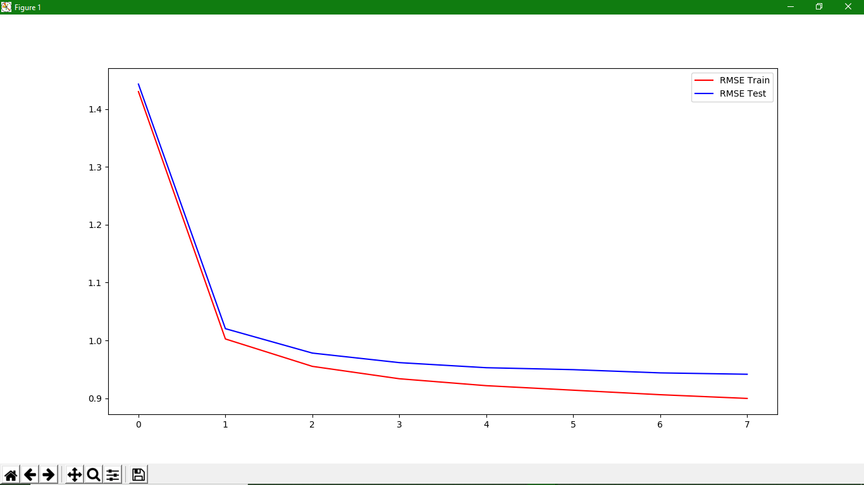

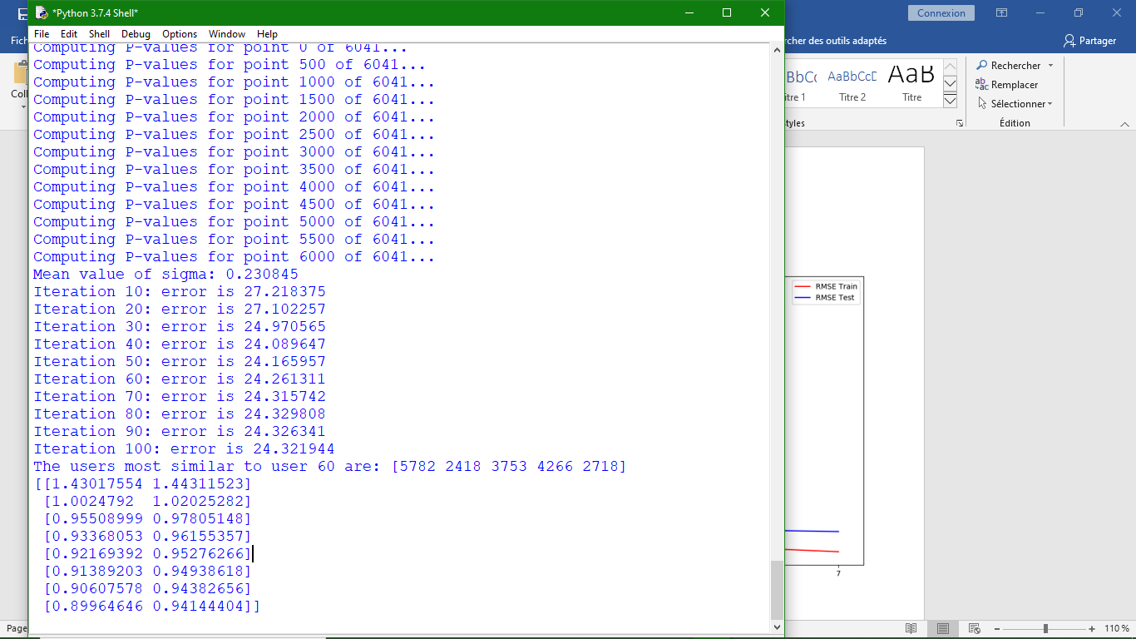

LR 1e-2 : Data split in 8 x 3 steps

Visualisations seem consistent (images) but too dense.

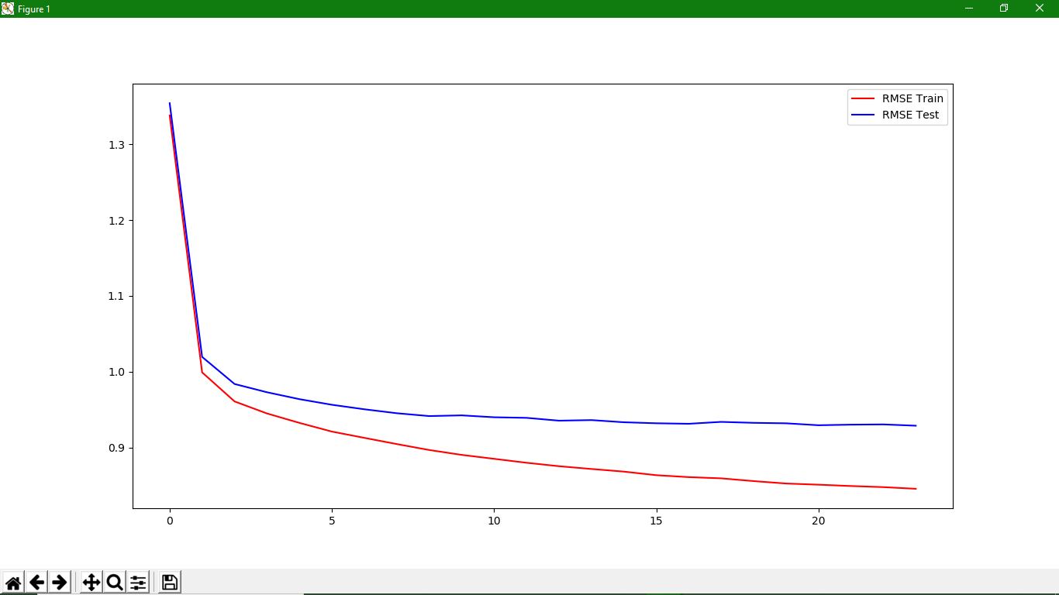

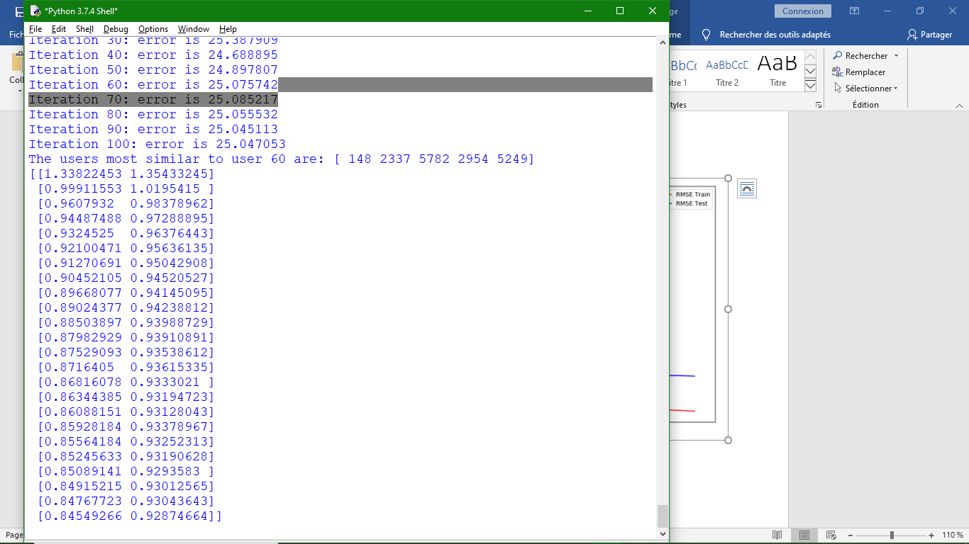

LR 5e-3 : Data split in 8 x 3 steps (perplexity 20)

Visualisations seem consistent (images) but too dense.

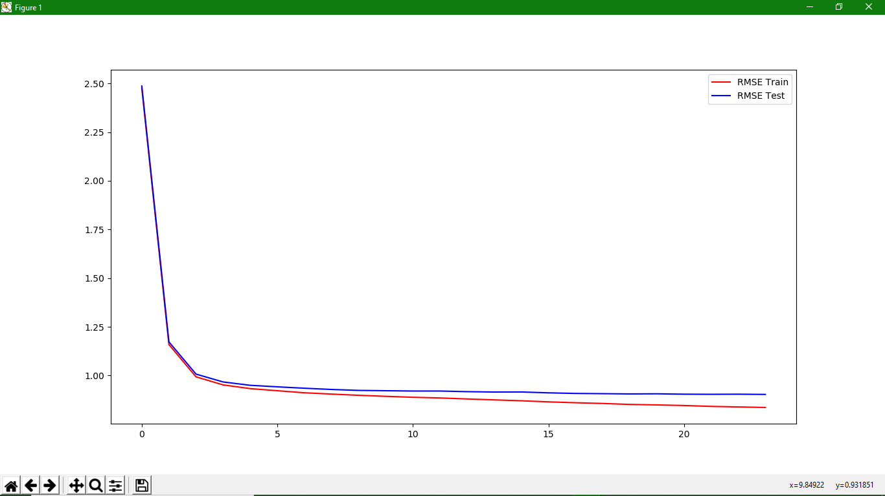

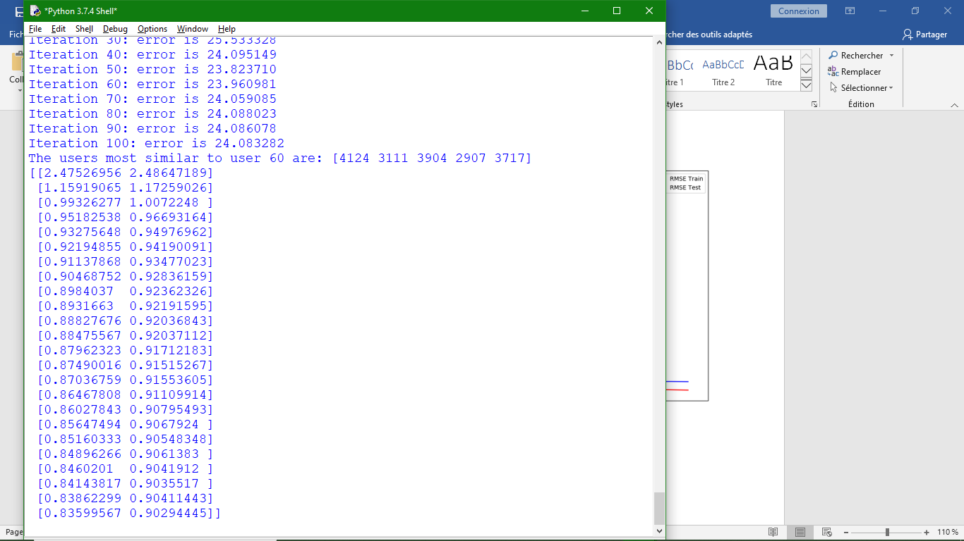

LR 5e-3 : Data split in 8 x 2 steps (perplexity 5)

Visualisation shapes have odd shapes.

